**OOP JAVA PROJECT**

Contents

Car rental application project 2

Goal: 2

Program Description: 2

Implementation requirements 4

Deliverables 4

Resources 4

**Group D**

# Car rental application project

## Goal:

The goal of the project is to enable the customers to rent a car for the desired duration. The application will also support car rental company to manage the bookings made by the customers.



**Java Classes to represent the entities, retrieve information, update records in the database, generate reports**

**GUI for customers and employees**

**Text files storing necessary data**

**OR**

**SQL Server/MySQL database containing necessary tables and relationships**

## Program Description:

In this program you will write a set of supporting classes for a car renting application. Here is an example of GUI.

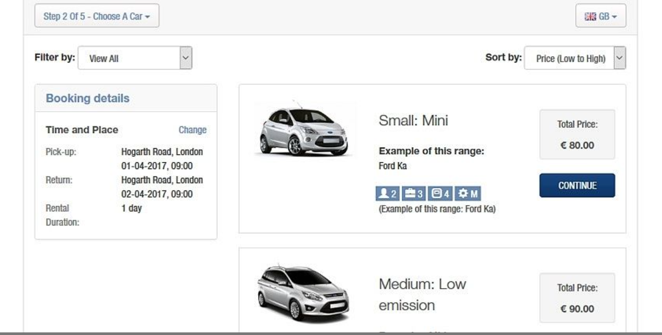

The application should allow the customers to browse through all the available cars of different types. For a desired duration, the customers will be able to book the chosen car for renting.

The customer will be of two types: new customers or member customers. New customers will be required to register and will be able to book without any discounts offered. The member customers could be individual or business. The member customers will have a login and will be able to book the car with discount offered based on the type of the member.

You are expected to create a dummy screen to indicate the processing of payments.

The application primarily involves details of the available car, their features and per day prices as well as customer orders generated and maintained.

The application should be developed for two types of users:

1. Customers – Book the rental for the car, Bill calculation with/without discounts, browsing the availability etc.
2. Employees – Update the currently available cars, introducing various discount offers, maintain the customer records, review popularity of cars etc.

You are expected to design and develop the database for this application along with the Java classes necessary to implement the application.

## Implementation requirements

* Necessary classes, methods and attributes should be designed using UML diagram notation. All the classes, methods and attributes should be explained in your documentation. Please discuss the design with me before you start implementation.
* You should be able to identify and introduce inheritance and aggregation relationship wherever applicable
* Necessary GUI screens should be added for successful execution.
* Records should be maintained in the database. Your Java code is expected to read and write to multiple tables as required. OR you can create the necessary text files.
* Every table/text file must be populated with at least 6 records.
* Above picture is an example of GUI. Your GUI does not have to look exactly same.

## Deliverables

1. Java code: All the folders and files of the project developed on Eclipse or Netbeans with the sources, and Javadoc documentation with comments on classes and methods.

2. Include a file named readme.txt – this file should include guidelines about executing your project.

3. Tentative due date: 07th April 2022.

## Resources

**JDBC:**[https://www.jmdoudoux.fr/java/dej/chap-jdbc.htm](https://translate.google.com/translate?hl=en&prev=_t&sl=auto&tl=en&u=https://www.jmdoudoux.fr/java/dej/chap-jdbc.htm), (Author: Jean-Michel Doudoux)

**My SQL:**[http://dev.mysql.com/doc/refman/5.7/en/](https://translate.google.com/translate?hl=en&prev=_t&sl=auto&tl=en&u=http://dev.mysql.com/doc/refman/5.7/en/)

**SQL Server**: <https://docs.microsoft.com/en-us/sql/ssms/download-sql-server-management-studio-ssms?view=sql-server-ver15>

**Wireframe:**[https://webdesign.tutsplus.com/articles/a-beginners-guide-to-wireframing--webdesign-7399](https://translate.google.com/translate?hl=en&prev=_t&sl=auto&tl=en&u=https://webdesign.tutsplus.com/articles/a-beginners-guide-to-wireframing--webdesign-7399)